Assignment-6 docker compose
Create a docker-compose.yaml file. Create 2 services in it httpd service and tomcat service, create 2 separate networks on those services n1 and n2. Put this docker-compose.yaml on github and needs to be accessed from there. Put thehttpd index file and tomcat sample.war on s3 bucket. Need to download from bucket.
Write Jenkins declarative pipeline where first we will download the files from s3 bucket and then run the docker-compose.yaml file

- Docker-compose.yaml file
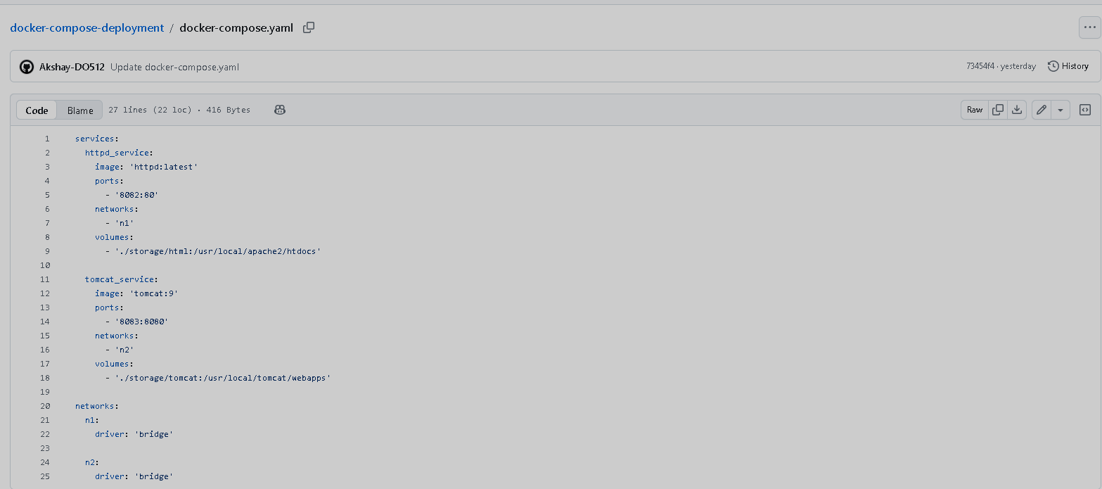

- Jenkins declarative pipeline
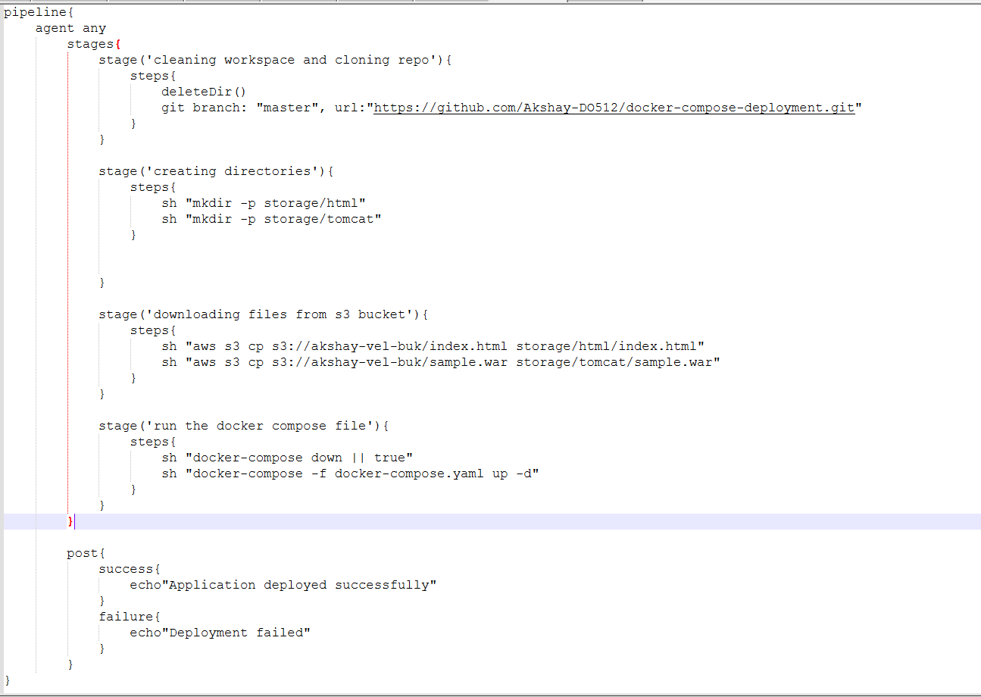

- Output:
httpd
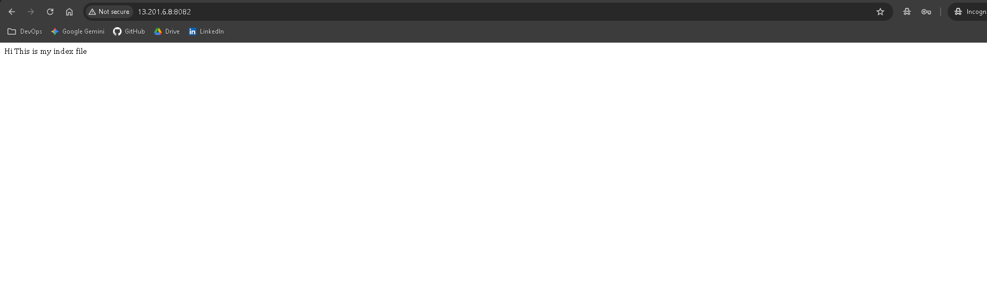

Tomcat
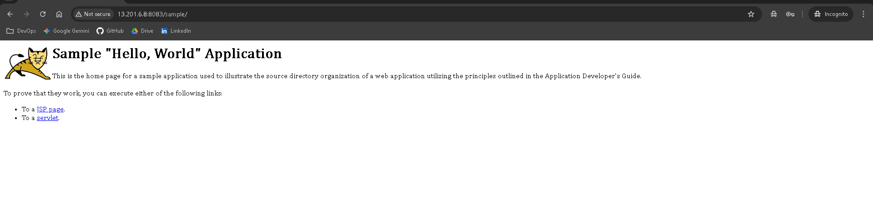

Note: Check the file permission on containers as well as on the EC2

